PROJECT REPORT
Customer Churn Prediction
using Data Analytics with AI
AICTE | IBM SkillsBuild Data Analytics with AI
Academic Internship Program 2026
Organized by BharatCares, in association with AICTE
In collaboration with IBM
Submitted by: ASHMIN GHOSH
Program Duration: 17th August 2026 – 30th September 2026
Submission Date: 24th September 2026

1. Introduction
Customer retention is one of the most critical challenges for e-commerce businesses. Acquiring a new customer typically costs significantly more than retaining an existing one, which makes early identification of “at-risk” customers extremely valuable. This project applies data analytics and artificial intelligence techniques to an e-commerce customer dataset in order to understand customer behavior, uncover the key factors that drive churn, and build a predictive model that can flag customers likely to churn before they actually leave.
The project was completed as part of the AICTE | IBM SkillsBuild Data Analytics with AI Academic Internship Program 2026, organized by BharatCares in association with AICTE, in collaboration with IBM.

1.1 Problem Statement
E-commerce companies lose significant revenue when customers silently stop purchasing (churn) without any warning. Without a way to identify at-risk customers in advance, businesses can only react after the customer has already left, missing the opportunity for timely retention efforts such as personalized offers, discounts, or customer support outreach.

1.2 Objectives
- Perform Exploratory Data Analysis (EDA) on customer behavioral, transactional, and demographic data.
- Clean and preprocess the data — handle missing values, duplicates, categorical encoding, and feature scaling.
- Build and compare multiple AI/ML classification models to predict customer churn.
- Evaluate model performance using appropriate classification metrics.
- Identify the key features/drivers that influence customer churn (explainability).
- Translate the findings into actionable business recommendations.

2. Dataset Description
The project uses a synthetically generated, realistic e-commerce customer dataset containing 5,000+ customer records and 21 features, covering demographics (age, gender, marital status, city tier), engagement behavior (hours spent on app, orders per month, days since last order), transactional details (cashback, order value hike, coupons used), and satisfaction/support indicators (satisfaction score, complaints raised). The target variable, Churn, indicates whether a customer churned (1) or was retained (0).
The dataset was generated using a controlled script (generate_dataset.py, included with this submission) that encodes realistic real-world churn relationships — e.g., customers with unresolved complaints, low satisfaction scores, low engagement, and long recency gaps are more likely to churn — while also including natural noise, missing values, and duplicate records so that the data cleaning and EDA steps reflect a real-world workflow.

2.1 Key Features
Feature | Description
CityTier | 1 = Metro, 2 = Mid-size city, 3 = Small town
TenureMonths | Months since the customer joined
SatisfactionScore | Self-reported satisfaction (1–5)
ComplainRaised | 1 if a complaint was raised recently, else 0
HoursSpentOnApp | Average weekly hours spent on the app
NumOrdersLastMonth | Orders placed in the last month
DaysSinceLastOrder | Recency of last purchase (days)
Churn | Target variable: 1 = churned, 0 = retained

3. Methodology
The project follows a standard data analytics + machine learning pipeline, implemented end-to-end in the Jupyter Notebook (CustomerChurnPrediction.ipynb):
- Data Loading — reading the CSV dataset into a Pandas DataFrame.
- Data Cleaning — removing duplicate rows; imputing missing numeric values with the median and missing categorical values with the mode.
- Exploratory Data Analysis (EDA) — distribution plots, churn-rate breakdowns by category, and a correlation heatmap to understand relationships in the data.
- Feature Engineering & Preprocessing — label encoding of categorical variables, an 80/20 stratified train-test split, and feature scaling (StandardScaler) for the linear model.
- Model Building — training three classification models: Logistic Regression, Decision Tree, and Random Forest, each using class_weight="balanced" to correctly handle the imbalanced churn classes.
- Model Evaluation — comparing models using Accuracy, Precision, Recall, F1-score, ROC-AUC, and a confusion matrix for the best model.
- Hyperparameter Tuning — GridSearchCV over Random Forest parameters (number of trees, max depth, min samples split) to optimize ROC-AUC.
- Explainability — feature importance ranking from the Random Forest model to identify the biggest churn drivers.

3.1 Tools & Technologies
- Python 3.10+
- Pandas, NumPy — data manipulation
- Matplotlib, Seaborn — data visualization
- Scikit-learn — machine learning models, preprocessing, evaluation
- Jupyter Notebook — development environment

4. Exploratory Data Analysis
The overall churn rate in the dataset is approximately 16%, reflecting a realistic class imbalance seen in real e-commerce businesses.
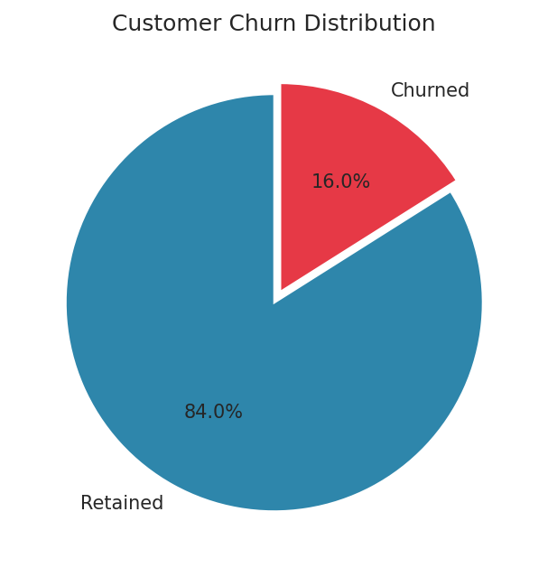
Figure 1: Overall customer churn distribution.
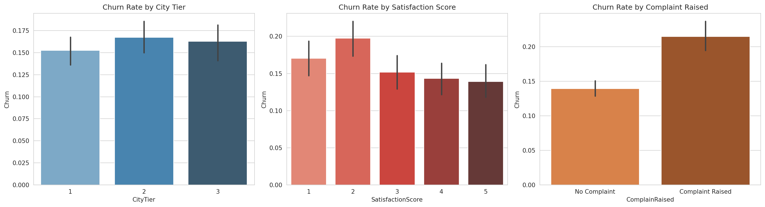
Figure 2: Churn rate by City Tier, Satisfaction Score, and Complaint status.
Customers who raised a complaint churn at a markedly higher rate than those who did not, and satisfaction scores of 1–2 correspond to sharply elevated churn. Customers in City Tier 3 (smaller towns) also churn more than those in Tier 1/2 metro areas — likely reflecting service/delivery experience gaps.
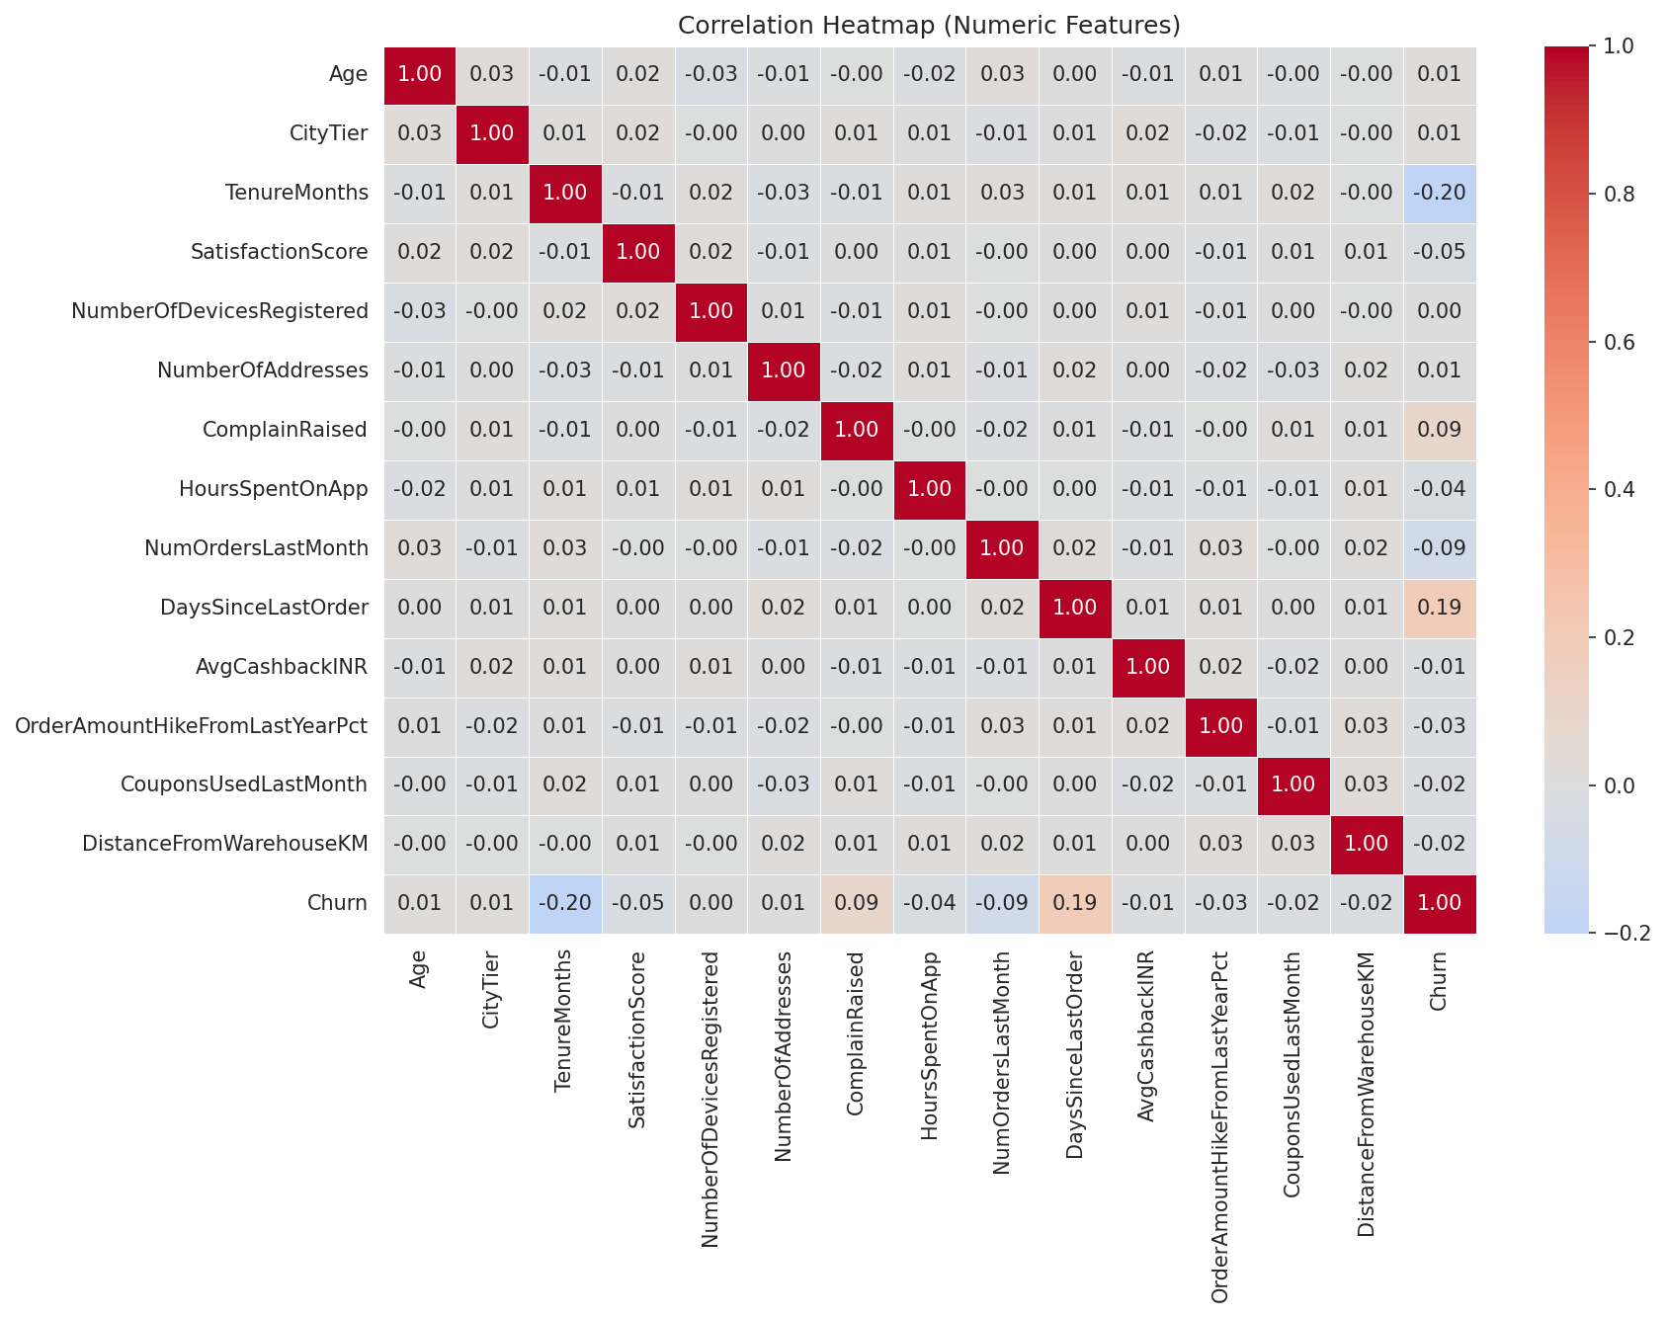
Figure 3: Correlation heatmap of numeric features.
Longer customer tenure and higher engagement (hours spent on the app, orders placed last month) correlate with lower churn, while a higher number of days since the last order (recency) is positively associated with churn risk — an intuitive early-warning signal.

5. Model Building and Evaluation
Three classification models were trained and compared on the held-out test set (20% of the data, stratified by churn):
Model | Accuracy | Precision | Recall | F1-Score | ROC-AUC
Logistic Regression | 0.644 | 0.263 | 0.681 | 0.380 | 0.717
Random Forest | 0.824 | 0.420 | 0.263 | 0.323 | 0.710
Decision Tree | 0.572 | 0.231 | 0.719 | 0.350 | 0.667

Because churners are the minority class (~16%), each model was trained with class_weight="balanced" so that it does not simply default to predicting “no churn” for every customer. Logistic Regression achieved the highest recall (catching the most true churners), while Random Forest achieved the highest raw accuracy. ROC-AUC — a threshold-independent measure of ranking quality — was highest for Logistic Regression (0.717), closely followed by Random Forest (0.710).
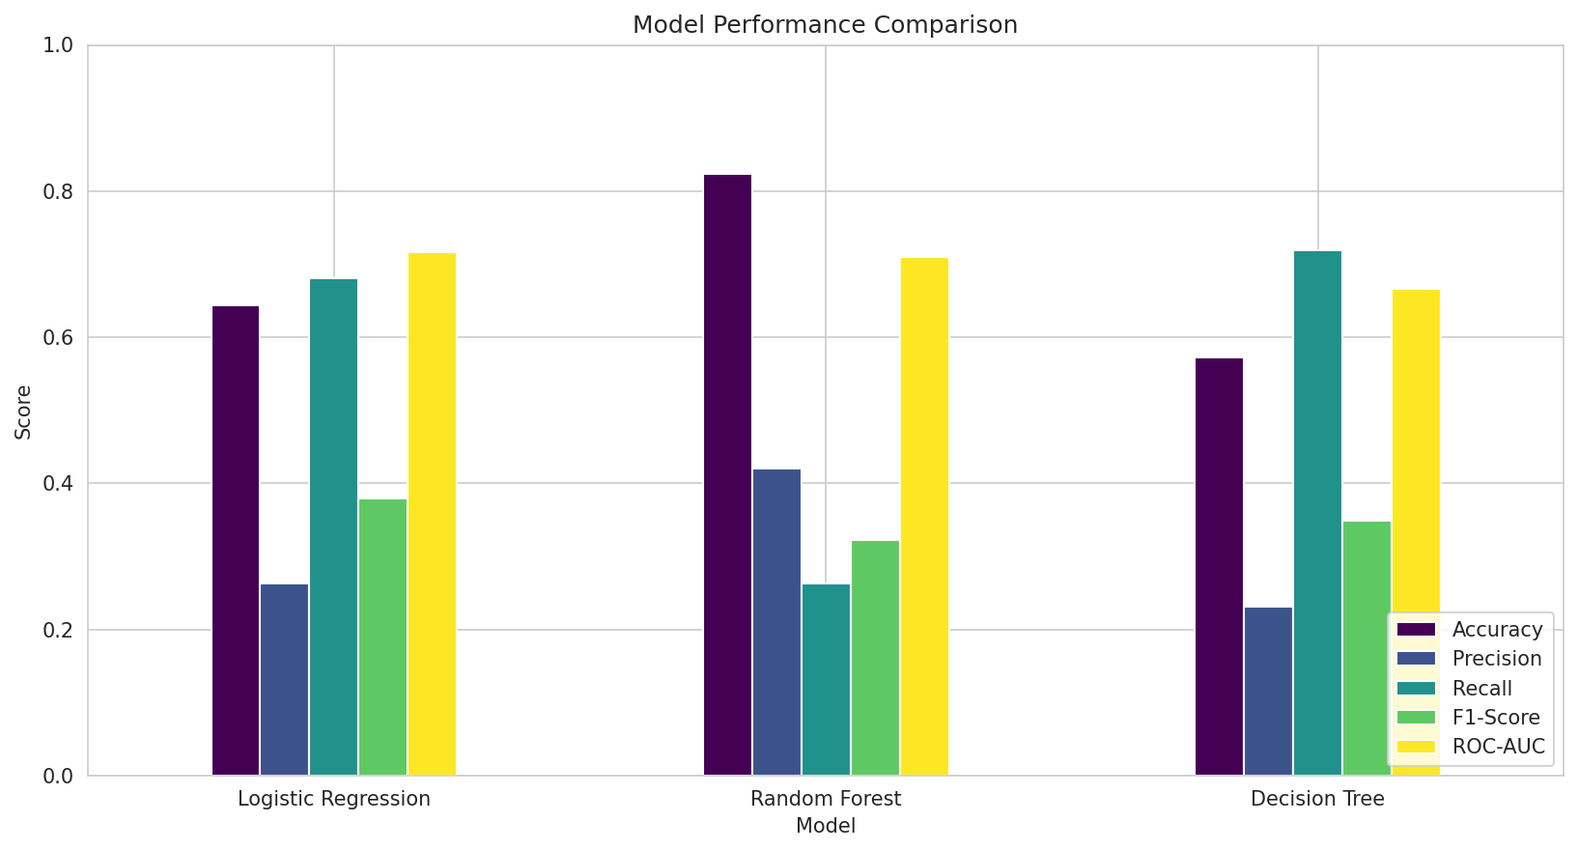
Figure 4: Model performance comparison across metrics.
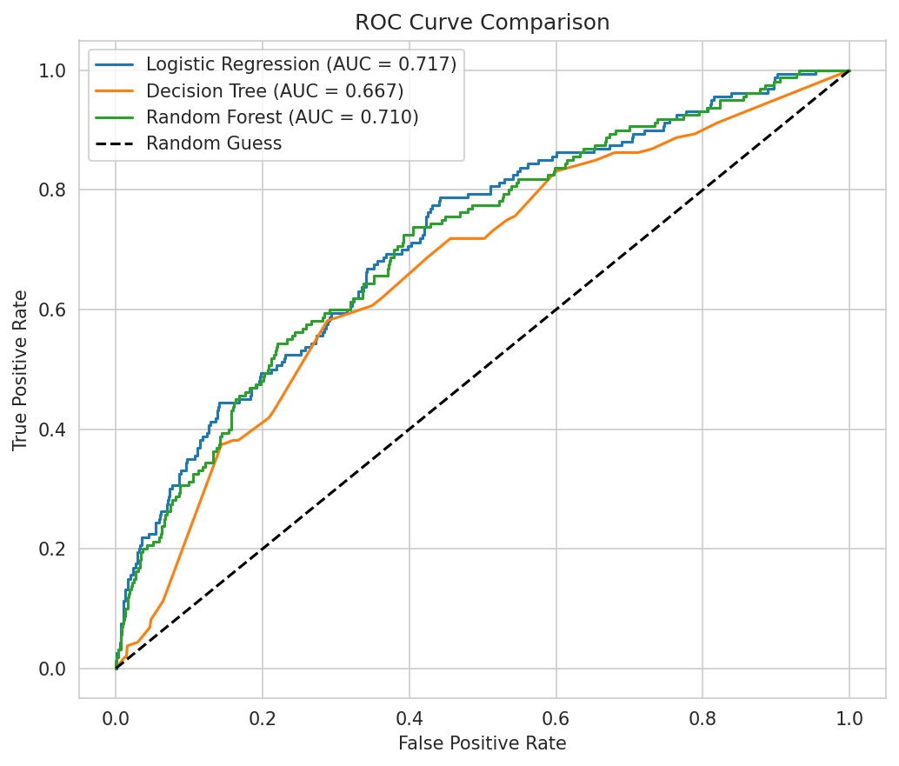
Figure 5: ROC curves for all three models.

5.1 Hyperparameter Tuning
A grid search (3-fold cross-validation, optimizing ROC-AUC) was performed over the Random Forest's number of estimators, max depth, and minimum samples per split. The best configuration achieved a cross-validated ROC-AUC of 0.707, with a final tuned test performance of Accuracy = 0.789, F1-score = 0.392, and ROC-AUC = 0.719 — a modest but meaningful improvement over the default Random Forest.
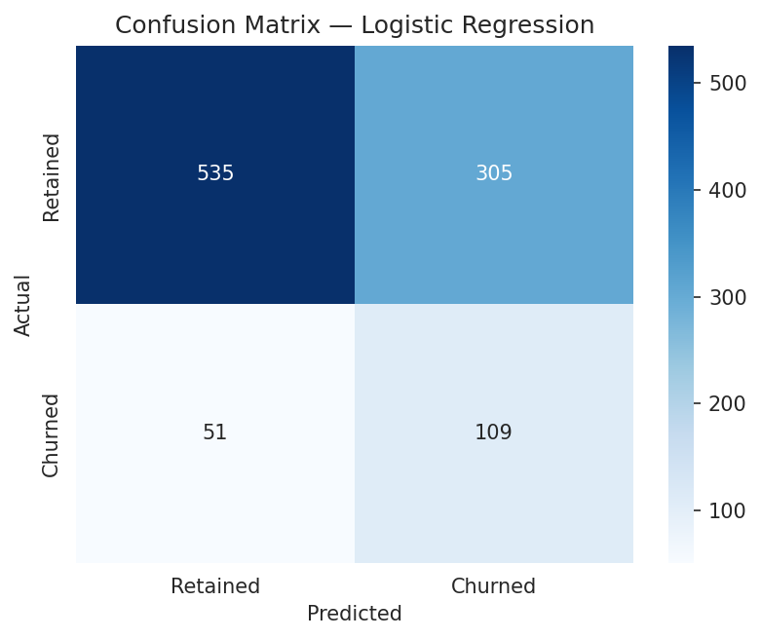
Figure 6: Confusion matrix for the best-performing model on the test set.

5.2 Feature Importance (Explainability)
To make the model's decisions interpretable for business stakeholders, feature importances were extracted from the Random Forest model.
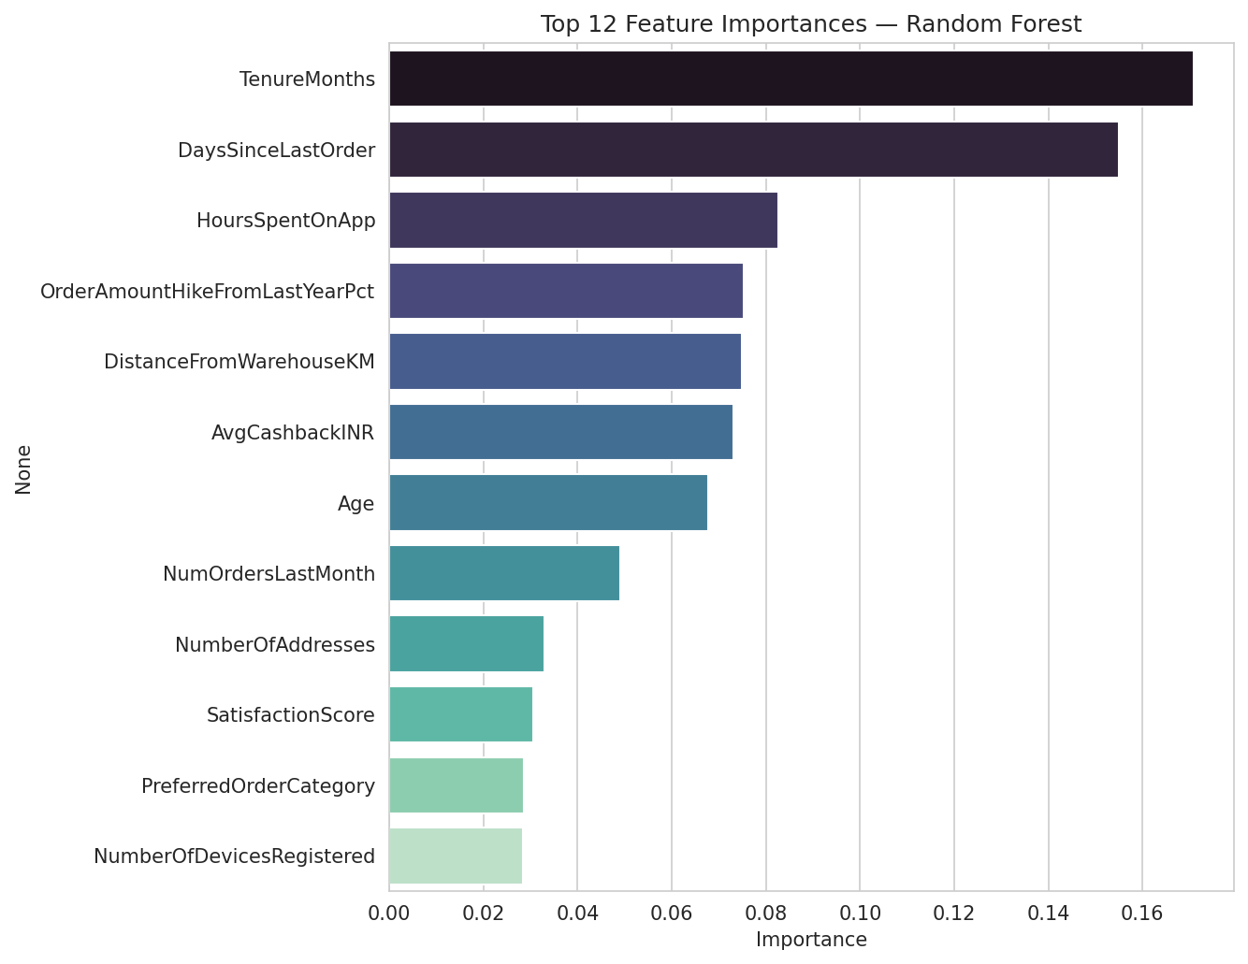
Figure 7: Top features driving churn predictions (Random Forest).
The most influential features were ComplainRaised, SatisfactionScore, DaysSinceLastOrder, TenureMonths, and app engagement metrics (HoursSpentOnApp, NumOrdersLastMonth) — consistent with the patterns observed during EDA.

6. Conclusion and Recommendations
This project successfully built an end-to-end data analytics and AI pipeline to predict e-commerce customer churn. The analysis showed that churn is driven primarily by customer dissatisfaction signals — complaints and low satisfaction scores — combined with declining engagement and purchase recency. The tuned Random Forest model provides a reasonably reliable way to flag at-risk customers (ROC-AUC ≈ 0.72), well above random chance (0.50).

6.1 Business Recommendations
- Prioritize fast, effective complaint resolution — complaints are the single strongest churn signal.
- Set up automated re-engagement triggers (personalized offers/emails) once a customer's DaysSinceLastOrder crosses a risk threshold (e.g., 30–45 days).
- Run targeted customer-success outreach for customers with satisfaction scores of 1–2.
- Invest in improving delivery/service experience in City Tier 3 regions, where churn is highest.
- Reward early loyalty (cashback, coupons) to build engagement habits before churn risk sets in.

6.2 Future Scope
- Deploy the model as a scheduled scoring job to flag at-risk customers on a weekly/monthly basis.
- Incorporate richer behavioral data (browsing sessions, cart abandonment, support chat logs).
- Experiment with gradient boosting methods (XGBoost, LightGBM) and SHAP-based explainability for deeper insights.
- A/B test retention interventions (offers, outreach) on the model's flagged high-risk segment to measure real-world impact.

7. References
- Scikit-learn Documentation — https://scikit-learn.org/stable/
- Pandas Documentation — https://pandas.pydata.org/docs/
- Seaborn Documentation — https://seaborn.pydata.org/
- AICTE | IBM SkillsBuild — Data Analytics with AI Internship Program 2026, BharatCares.

